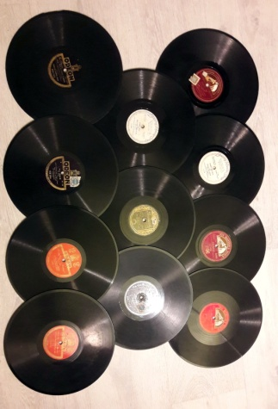

Disques 78 tours

* COLUMBIA
- "dans la forêt" / "les châteaux" M. Jean Clément
- "le chant du vaquero" / "dans mes yeux" M. Jean Sorbier
- "souviens-toi" / "ce n 'était pas vous" M. Jean Sorbier
- "ukulele lady" / "banana oil" Vaughn de leath
- "mama...yo quiero un novio- tango" / "maniqui-tango" orquesta argentina Rolando du Perron
- "deep river" / "thou art risen my beloved" Sung by Turner Layton
- "ciribiribin" / "all or nothing at all" Frank Sinatra
- "haïti" / "c 'est lui" Joséphine Baker
- "le paradis perdu" / fumée Lucienne Delyle
- "lettre a nini" / c'est mon quartier Lucienne Boyer
- "biguine a bango" / "annie-anna" Charles Trenet
- "serenade les millions d'arliquin" / "si mes vers avaient des ailes" J. Lensen
- "deep purple" / i can't cet you of my mind" Carroll Gibbons

* POLYDOR
- "au vent léger" / "une charade" Danielle Darieux
- "dog-swing / bib-bap Fredy Jumbo

* BRUNSWICK
- "my mammy" / "golden gate" Al.Jolson
- "the way you look to-night" / "pick yourself up " Fred Astaire

* PARLOPHONE
- "pour ton amour j'aurais donné ma vie" / "je t'ai donné mon cœur" Guy Berry
- "all of my life / "jeanie with the light brown hair" Stephen Manton

* ODEON
- "pour un seul mot d'amour" / "tu sais" Yvonne Guillet
- "yo no se porque te quiero" / el tigre millan l'orchestre Argentin Canaro

* PATHE
- "chalita" / "sheherazade" Jovatti

* LIBERTY MUSIC SHOP
- "ridin' high and red, hot and blue" / "you've got something and it's de-lovely" Fairchild and Carroll
- "johnny one note and where or when" / "babes in arms and i wish in love again Fairchild and Carroll

* HIS MASTER'S VOICE
- "oh ! what a beautiful city" / "let us break break together" Marian Anderson
- "afraid to dream" / "can l forget you" Jean Sablon

*GRAMOPHONE
- "tabou - son" Oscar de la ROSA / "alo....alo" ? Carmen Miranda-Mario Reis

* PARLOPHONE
Il y a aussi des disques en plastique souple HIT OF THE WEEK
- lawd,you made the night too long
- an evening in Caroline
- was that the human thing to do
- you try somebody else
- lullaby of the leaves betty boop
- blue again
- out of nowhere
- it's the girl
- soft lights and sweet music

Faire une proposition de prix

